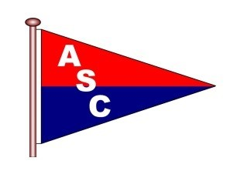 | Ashlett Sailing Club  Mooring Application

Following completion of this application please email it to the Moorings Manager – Keith Guy-Gibbens
keeffgg@yahoo.co.uk

Name: | Click or tap here to enter text. | Membership No: | Click or tap here to enter text.
Address: | Click or tap here to enter text. | (if applicable)
 | Click or tap here to enter text. | Mobile: | Click or tap here to enter text.
 | Click or tap here to enter text.
Post Code: | Click or tap here to enter text. | Email: | Click or tap here to enter text.
Date of Joining ASC (if applicable) |  | Click or tap here to enter text.

Vessel Details

Name: | Click or tap here to enter text. |  |  |  |  | Model/Class: |  | Click or tap here to enter text.
Type of Vessel |  |  | Choose an item.
LOA: (ft) | Click or tap here to enter text. |  |  | Beam: (ft) | Click or tap here to enter text. |  |  | Draft: (ft) | Click or tap here to enter text.
Tonnage : |  | Click or tap here to enter text. |  |  |  |  | Keel Type | Choose an item.

Present Mooring number (if applicable) | Click or tap here to enter text.

Are you on the waiting list | Choose an item. | Would you like to be added to the waiting list | Choose an item.

Payment: You will be invoiced for the fees due – do NOT make any payment now

Fees schedule | South Bank | £9.00 per foot per annum
For information only | North Bank | £8.00 per foot per annum
 | Water Mooring | £7.00 per foot per annum

DECLARATION

I agree to be bound by the Rules of the Ashlett Sailing Club Ltd.

Signed (or name) | Click or tap here to enter text. | Date | Click or tap here to enter text.

